Before proceeding, ensure that you have the PTS brand dongle plugged DIRECTLY into your PC, not into a hub or other device (even an extension cable).

- With the Device Manager OPEN, remove the PTS dongle and see what device disappears. Re-insert the dongle and right click on the device and select “UPDATE DRIVER SOFTWARE…”
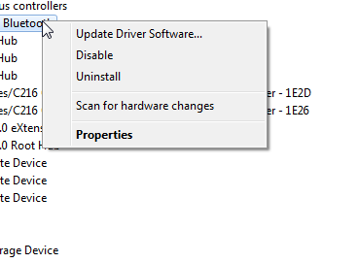

- Select “Browse my computer for driver software”
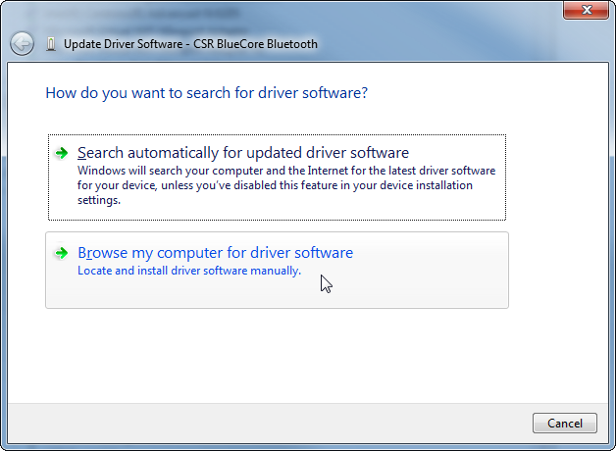

- Select “Let me pick from a list of device drivers on my computer”
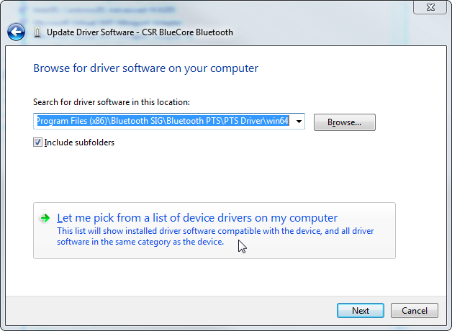

- Select “Have Disk…”
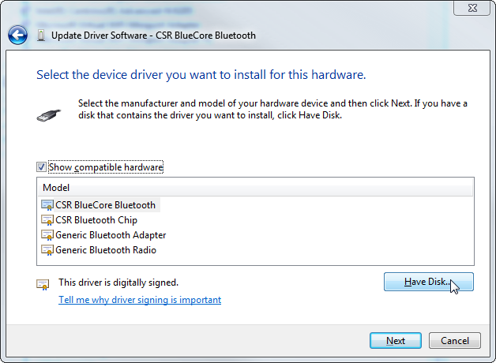

- Select “Browse…”
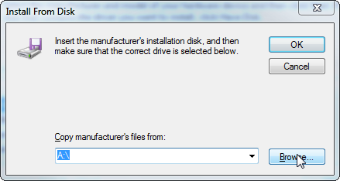

- Look in the location where you installed the PTS
The default is:
C:\Program Files (x86)\Bluetooth SIG\Bluetooth PTS\PTS Driver\win64 (64 bit machines) or
C:\Program Files\Bluetooth SIG\Bluetooth PTS\PTS Driver\win32 (32 bit machines)
And select the driver and click “OPEN”
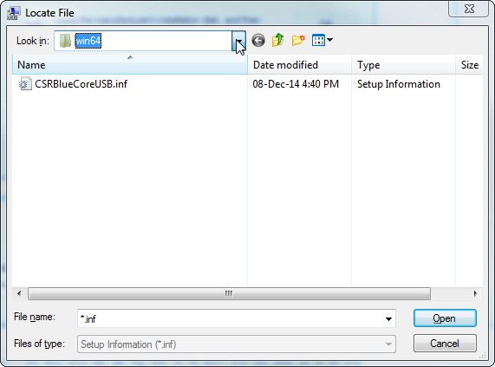

- Click “OK”
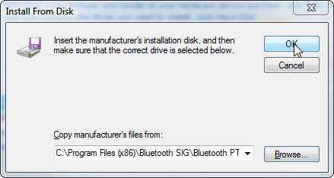

- Driver should show as “CSR BlueCore Bluetooth”, select and click “Next”.
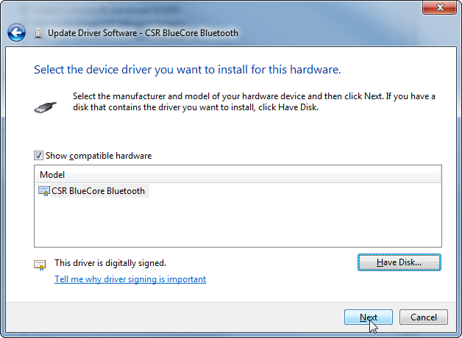

- You will now see that your driver is successfully installed! Click “Close”
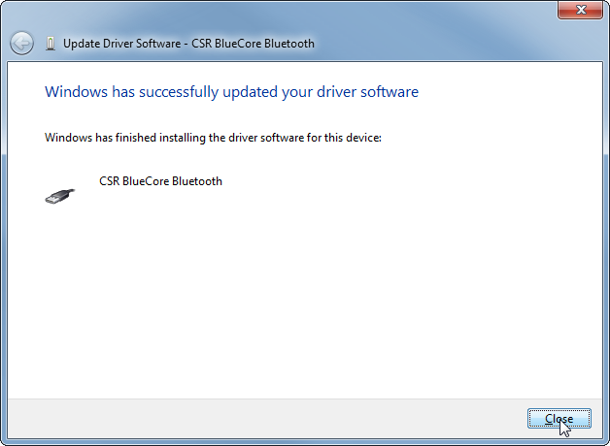

- Verify that you now see the dongle listed in the “Universal Serial Bus controllers” as CSR BlueCore Bluetooth
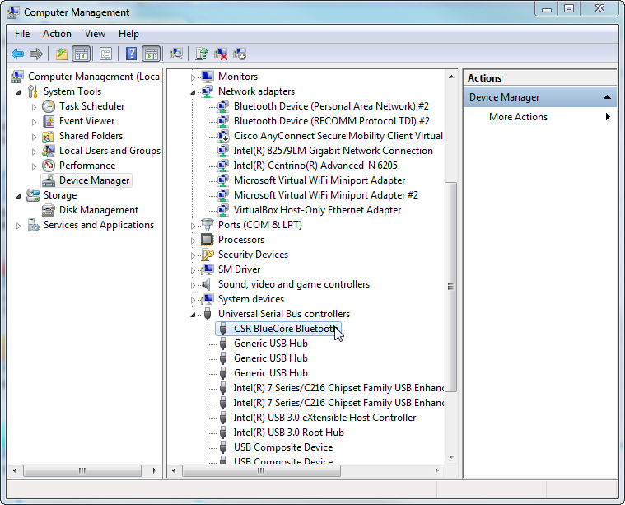

Trouble Shooting:
If you have tried the above, and it all looks good but the PTS is still not seeing the driver or if you accidentally tried to install the wrong driver, try the following:

In the Device Manager, right click on the CSR BlueCore Bluetooth device under Universal Serial Bus Controllers and select Uninstall
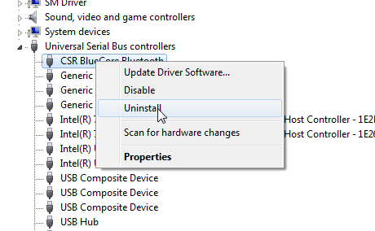
Next, CHECK the box “Delete the driver software for this device.” And click “OK”
Then redo steps 1-10 above.
NOTE: This will uninstall the device and remove the installed driver (will not remove the driver file for the PTS files)
